

Syncope OpenSource IdM
Managing Identities in Enterprise Environments
Version 1.2 / 2011-12-16


Syncope OpenSource IdM by http://syncope.googlecode.com/ is licensed under a Creative Commons Attribution 3.0 License. To view a copy of this license, visit http://creativecommons.org/licenses/by-sa/3.0/
Table of Contents
1 Executive summary 3
2 Requirements for an effective Identity Infrastructure 4
2.1 Identity Lifecycle Management 6
3 Syncope, Open Source IdM 8
3.1 Why Open Source 8
3.2 High-level Architecture 9
3.2.1 Syncope core logic 10
3.2.2 RESTful controllers 10
3.2.3 Workflow engine 10
3.2.4 JPA persistence layer 10
3.2.5 Connectors layer 10
4 Some achievements 12

List of Figures
Figure 1: No IAM organization 5
Figure 2: IAM-enabled organization 5
Figure 3: Identity Lifecycle 7
Figure 4: High-level Syncope architecture 9

Executive summary
Identity management (or IdM) represents the joint result of business process and IT to manage user data on systems and applications. IdM involves considering user attributes, roles, resources and entitlements in trying to give a decent answer to the question bumping at every time in IT administrators' mind:
Who has access to What, When, How, and Why?

Inside a given organization, an IdM solution will basically
- provide the right information and tools to the right people, at the right time;
- enable approval process and delegation of authority;
- protect IT infrastructure from information theft;
- help the organization to comply with regulations;
- ensure the privacy of customer, partner and employee information;
- facilitate the creation and automate the enforcement of business policies that strengthen security, reduce administration costs and improve productivity.
Conversely, when not implementing an IdM solution, an organization can easily fall into situations in which, for example, new-hired and promoted employees sit idle waiting for granted access to needed tools while former employees can continue to have access for days and weeks after they left the organization. Moreover, compliance process cannot rely upon a verifiable, accurate and timely control over the identities of the people and resources distributed across the organization itself.

This paper introduces a new approach to build and maintain the identity management infrastructure by leveraging the fresh and rising IdM Open Source product called Syncope. In the following, this paper will examine what is required of an identity infrastructure today and introduce Syncope specifications, architecture and technicalities.

Requirements for an effective Identity Infrastructure
Building an identity infrastructure means often taking care of two distinct but tightly related aspects in IT management: identity management and access management; for this reason the preferred term to be used in this context is IAM (Identity and Access Management).
A complete IAM solution provides:
- identity lifecycle management (with workflow-based provisioning)
- meta-directory
- access control
- role-based management
- self-service functionalities
A key aspect to outline is that an IAM solution needs to do its job by leveraging – rather than replacing – existing business processes, business rules and technology investments.
Let's consider the situation depicted in Figure 1: a very common scenario in which different groups of users (partners, employees, customers, former employees) have all different ways to access the various systems and applications provided by the organization. Each separate system stores its own username, password, user profile and authorizations. Authorization process is completely independent and delegated to each single application.
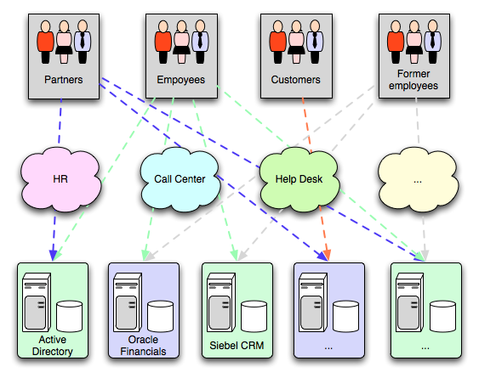Figure 1: No IAM organization
By introducing a complete IAM solution, the situation becomes similar to what shown in Figure 2: the centralized IAM system takes care of all security aspects of the communication between users and applications, synchronizes information among different systems, performs auditing and logging of all the processed transactions – if required.
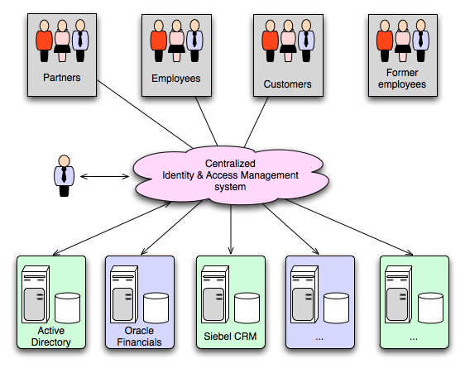Figure 2: IAM-enabled organization

Identity Lifecycle Management
As suggested by what stated above, one of the most important concepts in a successful IAM solution is the processes and technology used to create and delete accounts, manage account and entitlement changes and track policy compliance, including some or all of the following:
- Provisioning / de-provisioning
The automatic creation and expiration of accounts in multiple systems based on data from authoritative data sources, thereby reducing the administrative effort involved in manual account creation and management, and reducing security risk by the automatic application of policies.
- Workflow
The automation of steps within the identity lifecycle management process including notification, approval, escalation and creation of audit data.
- Administration
The facilitation of the administration of identities, usually through the deployment of a web-based user administration console. Such interfaces are often used for delegated administration and possibly even user self-service, in conjunction with workflow.
- Credential management
Passwords, certificates and smart cards.
- Role management
Where Role Based Access Control (RBAC) is in use, facilities for the creation and maintenance of roles, including role definition and role membership.

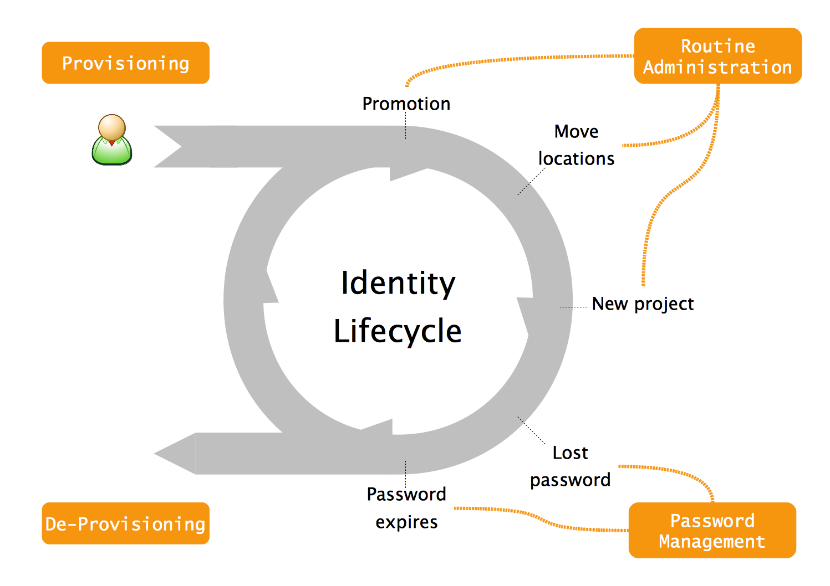Figure 3: Identity Lifecycle

Syncope, Open Source IdM
Syncope (http://www.syncope-idm.org/) is an IdM solution, implemented in J2EE technology and released under Apache 2.0 license (http://www.apache.org/licenses/LICENSE-2.0.html).
Syncope features most of what expressed above in terms of pure identity management. For deployment scenarios in which access management features are requested as well, Syncope perfectly fits together with some Open Source access management solutions, like as OpenAM (http://forgerock.com/openam.html) or CAS (http://www.jasig.org/cas/).
In order to run Syncope, a J2EE container (Apache Tomcat, for example) and a DBMS are only needed. Most of DBMS available either on the market or in the Open Source space are fully supported.
Syncope source code is at the moment hosted by GoogleCode and managed as an Apache Maven 3 multi-module project. Stable Maven artifacts are regularly published to central repository at http://repo1.maven.org/maven2/org/syncope/, while snapshot releases are available at https://oss.sonatype.org/content/groups/public/org/syncope/.
As many other modern Open Source projects, Syncope is built upon solid foundations, made in turn by other Open Source projects. Some of them are reported below:
- Spring (http://www.springsource.org/)
- Hibernate (http://www.hibernate.org/)
- Activiti BPM (http://www.activiti.org/)
- EHCache (http://ehcache.org/)
- Quartz (http://www.quartz-scheduler.org)
- Apache Wicket (http://wicket.apache.org/)
- ConnId (http://connid.googlecode.com/)

Why Open Source
People that started Syncope inception and development got all the times stuck in license related issues, mainly about costs and bureaucracy.
They used to be able to successfully draft most of customers needs in terms of middleware, often obtaining very satisfactory results, by only using Open Source systems and tools. All that with a (very noticeable) exception: IdM. Nothing seemed to be found throughout the all Internet that was implementing what needed to fulfil customers' requirements.
At that point it became clear that the only way out was to respond to one of mostly heard sentences in modern IT: “Do you pine for the days when men were men and wrote their own device drivers?” [Torvalds, Linus and David Diamond (2001). Just for Fun: The Story of an Accidental Revolutionary. Collins. Notes: Announcing Linux version 0.02 [ibid]].
So, at the end, why Open Source? Because it's better!

High-level Architecture
From an high-level point of view, the component architecture of Syncope can be summarized by Figure 4. Syncope is composed by two main subsystems:
- the core
The web application that implements IdM features; it offers a RESTful interface for caller applications, implements the provisioning core by mean of its workflow engine and its propagation layer, manages data persistence.
- the console
The web management interface for configuring and administering Syncope core. Like as other external applications, the console communicates with the core by REST calls.

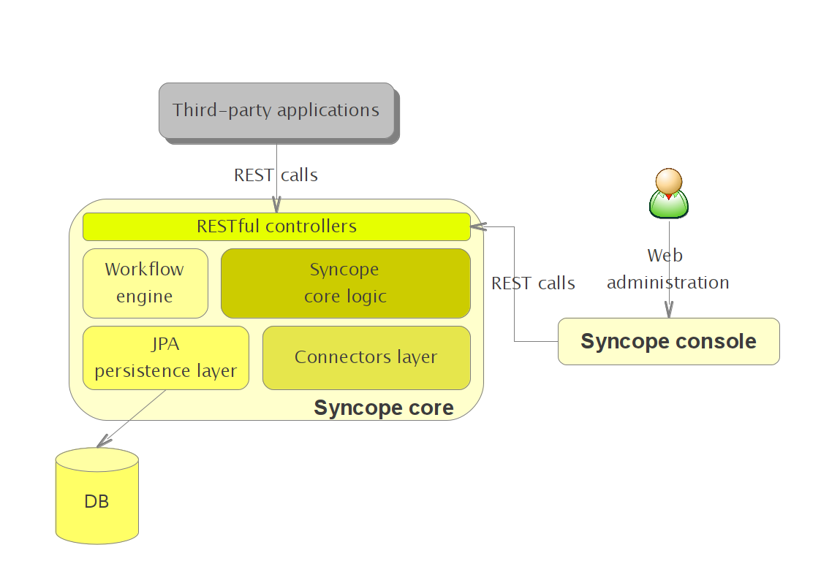Figure 4: High-level Syncope architecture

Syncope core logic
This central component orchestrates the whole data flow throughout the system. Gets involved upon RESTful calls, processes data alongside the defined workflow, propagates to and synchronize from configured external resources, if needed.

RESTful controllers
RESTful controllers take care of the communication with outside world. Implemented by leveraging Spring's REST and MVC features, these controllers exchange data in both XML and JSON formats.

Workflow engine
Workflow engine is a pluggable aspect of Syncope: this lets every deployment choose among one of provided engine implementations or define new, custom ones.
Syncope default implementation is based on Activiti BPM, reference Open Source implementation that supports the definition of an XML descriptor in which user lifecycle is defined. This aspect makes the whole system very flexible to adapt to different situations.
Default implementation also provides notification, approval, and end-user request management.

JPA persistence layer
All the data used by Syncope (users, roles, attributes, resources, …) is managed at an high level with a standard JPA 2.0 approach and persisted to underlying database.
The chosen JPA implementation – Hibernate – can be quite painfully changed at configuration level to other implementations like as EclipseLink, OpenJPA or even Oracle TopLink.
This approach makes Syncope to be successfully deployable on most DBMS without any modification on the source code; in order to have an idea of this possibility, take a look at http://docs.jboss.org/hibernate/core/3.6/reference/en-US/html/session-configuration.html#configuration-optional-dialects.
Currently, Syncope officially supports MySQL, PostgreSQL and Oracle DB.

Connectors layer
Connector layer is implemented with ConnId; ConnId is designed to separate the implementation of an application from the dependencies of the system that the application is attempting to connect to.
Connid is the continuation of Identity connectors, a project that used to be part of the market leader Sun IdM and have been released by Sun as an Open Source project. This makes the connectors layer particularly reliable since most connectors are already implemented in the framework and widely tested. Lately, the original project has been forked into the new ConnId project, whose main purpose is to provide all that is required nowadays for a modern Open Source project: Apache Maven driven build, artifacts and mailing lists. Additional connectors – like as SOAP, CSV and Active Directory – are also provided.
Syncope supports either
- propagation towards external resources (when user data is copied from Syncope to external resources)
- synchronization from external resources (when user data is pulled from external resources into Syncope)
Propagation and synchronization operations – a.k.a tasks – are saved for reporting and later re-execution.

Some achievements
Some relevant facts that have been achieved in more than one environment:
- > 2 million users
- > 50 million user attributes
- 30 roles
- > 3 million memberships
- > 12 million membership attributes
- customized workflow implementation with confirmation sent over as e-mail and SMS text
- customized console

